Exhibition Can it be tried somewhere?, NERO’s Publishing Experimentation on view at the International Centre of Graphic Arts in Ljubljana from 10. 3. till 28. 5. 2023 (Tivoli Mansion in Tivoli Park).

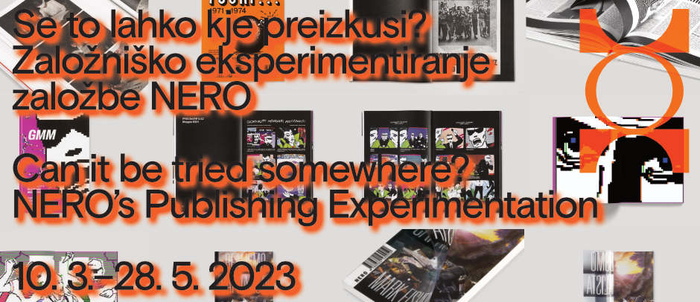

Can it be tried somewhere?
NERO’s Publishing Experimentation
10. 3.–28. 5. 2023

Opening of the exhibition on Friday, 10 March 2023, at 1 pm, at the International Centre of Graphic Arts in Ljubljana (Pod turnom 3, Ljubljana, Slovenia).

It was 2004 and the first copies of NERO, a new free-press magazine of contemporary art and culture, were printed in Rome. Influenced by cross-disciplinary interests, always within the macro-set of the contemporary arts, Francesco de Figueiredo, Luca Lo Pinto, Valerio Mannucci and Lorenzo Micheli Gigotti began a publishing project, eager to occupy spaces with ideas, be that museums, bars or social centres, in interdisciplinary and experimental ways to generate debate.

Within a few years, NERO became a quarterly English-language magazine, distributed in Europe, North America and in the hotspots of artistic production, as well as a publishing house specialising in artists’ books, editions and catalogues responding to the spontaneous need to connect to a broader cultural discourse, using art to explore the imaginaries of the world to come and the relevant issues of the present: from the critique of the Anthropocene to the human-machine relationship, from radical pedagogies to gender perspectives, from platform capitalism to new digital aesthetics.

It is within this framework and with this aim that the Not (NERO on Theory) series and its webzine were launched in 2018. With its publications that cross and dissolve the boundaries between philosophy, visual arts, science fiction, pop culture, politics and economics, Not introduced to Italy many titles by authors who had already attracted attention within international cultural debate but had not yet been translated. Today, some of these titles are almost indispensable reading for understanding the contemporary world and continue to find great resonance in a wide range of cultural circles. In memes as in bibliographies of university courses, song lyrics and art exhibitions, the legacy of Donna Haraway, Mark Fisher, the CCRU, Timothy Morton and Silvia Federici expands and transforms every day, reworking their instances in ever new formats and projects.

Accelerationism, queer theory, Afrofuturism, the Anthropocene, apocalyptic thinking. While these debates and macro-themes remain vital, in the realm of theoretical non-fiction and fiction, NERO is now turning its attention to new non-book formats – Medusa, an in-depth scientific-literary newsletter on the climate crisis; the podcast K-assandra, which explores the condition of youth in late pandemic capitalism; SUTH, a survey of sounds from the southern shores of the Mediterranean; or AMMASSO, a cycle of performances, debates and live sets to mark the fifth anniversary of the Not series – driven by the same original desire to develop unprecedented editorial experiments, investigations and processes of representation.

Middleman, the latest book by Honza Zamojski, which is an illustrative and poetic attempt to describe the Middleman, his everyday life and the reality that surrounds him, will be published by Nero Editions in May.

Concept of the exhibition: Davide Francalanci – NERO

-------------------------------------------------------------------------------------------------------------------------

ACCOMPANYING PROGRAMME

-------------------------------------------------------------------------------------------------------------------------

Honza Zamojski
Middleman
10. 3.–28. 5. 2023

In Honza Zamojski's latest exhibition, the eponymous Middleman plays various roles. He is a viewer who, upon entering the exhibition space, stands in the middle of the symmetrical architecture. He is also an author who mediates between the world of ideas and the material world by creating drawings, sculptures and texts. Middleman is also visualised as a simplified and symbolic puppet that can be moved by various forces.

Honza Zamojski's work has been seen in Ljubljana in the main exhibition of the 33rd Ljubljana Biennial of Graphic Arts Crack Up – Crack Down in 2019, as part of which he presented his installation The Gathering and The Meeting at DUM Project Space. He received the Audience Award for his installation.

Exhibition curators: Nevenka Šivavec, Yasmín Martín Vodopivec
-------------------------------------------------------------------------------------------------------------------------

HAHAHA / AHAHAH
From Art Practice to Typography
19. 5.–20. 8. 2023, City Art Gallery, Ljubljana (ground floor)
Opening event: Friday, 19. 5., at 19.00
The pop-up exhibition shows the development of the Rubin Sans font in the oeuvre of Honza Zamojski, from the introduction of individual letters in 2014 to the production of the complete version in 2022.
Authors of the exhibition: Honza Zamojski and Threedotstype
-------------------------------------------------------------------------------------------------------------------------
International symposium

Friday, 19. 5., 12.00–17.00, MGLC Tivoli Mansion (Lecture Room)

The symposium is an accompanying event to the artist's exhibition at MGLC and his pop-up exhibition at the City Art Gallery Ljubljana. It is dedicated to the diverse media and art practice of Honza Zamojski, and specifically to his original typography, which he constantly develops and incorporates into his work.
The symposium brings together several invited curators and experts from the fields of typography, design, visual poetry and artists' books.

The symposium is held in English.

-------------------------------------------------------------------------------------------------------------------------

INFORMATION
Exhibition Can it be tried somewhere? is on view from 10 March 2023 till 28 May 2023. Tuesday to Sunday from 10 am till 6 pm.
Press contact: Sanja Kejžar Kladnik, sanja.kejzar@mglc-lj.si, +386 41 373 916

